**Article of the Week**

***Sinkholes: Common, Costly and Sometimes Deadly (1530L)***

**Instructions: COMPLETE ALL QUESTIONS AND MARGIN NOTES**

**Read** the following article carefully and **make notes in the margin** as you read.

Your notes should include:

* Comments that show that you **understand** the article. (A summary or statement of the main idea of important sections may serve this purpose.)
* Questions you have that show what you are **wondering** about as you read.
* Notes that differentiate between **fact** and **opinion**.
* Observations about how the **writer’s strategies** (organization, word choice, perspective, support) and choices affect the article.

Your **margin notes** are part of your score for this assessment.

Answer the questions carefully in **complete sentences** unless otherwise instructed.

**Student ____________________________Class Period__________________**

Sinkholes: Common, Costly and Sometimes Deadly

***STORY HIGHLIGHTS***

* *Central Florida is particularly known for sinkholes*
* *The state lies on limestone bedrock and often sees the phenomenon*
* *Florida property owners filed 24,671 claims for sinkhole damage from 2006 to 2010*
* *Florida sinkhole claims cost insurers $1.4 billion in that period, state Senate report says*

**(CNN)** -- The kind of sinkhole that [suddenly opened up under a Florida home](http://www.cnn.com/2013/03/01/us/florida-sinkhole/index.html) is more common than you might think. Let's take a look at what causes them, where they happen and just how dangerous and costly they can be:

**What causes sinkholes?**

Many sinkholes form when acidic rainwater dissolves limestone or similar rock beneath the soil, leaving a large void that collapses when it's no longer able to support the weight of what's above, whether that be an open field, a road or a house. These are called "cover-collapse sinkholes," and it would appear this is what's happening in Florida, where the ground beneath the home suddenly gave way.

**Where do they happen?**

Sinkholes are particularly common in Florida, which rests on a nearly unbroken bed of limestone, according to the Florida Sinkhole Research Institute. Central Florida, including the Tampa area, is particularly known for sinkholes. In fact, Hillsborough County, where Thursday's collapse occurred, is known as part of Florida's so-called Sinkhole Alley, where two-thirds of insurance claims for sinkhole damage occur, according to a report prepared for state lawmakers in 2010. Other places that frequently see sinkholes include Texas, Alabama, Missouri, Kentucky, Tennessee and Pennsylvania, the U.S. Geological Survey says.

**Do all sinkholes collapse so dramatically?**

No, some merely cause the ground above to sag, or result in small ponds or saltwater marshes, the Florida Department of Environmental Protection says.

**How often do they happen?**

There do not appear to be any solid numbers, but the Florida Senate Committee on Banking and Insurance reported that insurers had received 24,671 claims for sinkhole damage in that state alone between 2006 and 2010. That's an average of nearly 17 claims a day, just in Florida.

**How dangerous and costly are sinkholes?**

Deaths and injuries from sinkholes are rare, but certainly not unheard of. For instance, in 2012, a 15-year-old girl died when her family's car fell into a Utah sinkhole, according to media accounts. But the holes are enormously costly. Insurance claims submitted in Florida alone between 2006 and 2010 totaled $1.4 billion, according the Florida Senate report.

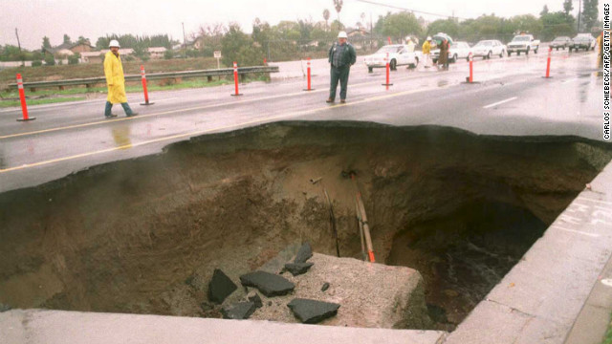

A 30-foot-deep sinkhole appeared in a busy street in a suburb east of downtown   
Los Angeles. A motorist drove into the hole but was rescued before a concrete slab   
fell onto the car.

***Notes on my thoughts, reactions and questions as I read:***

**Article of the Week**

***Sinkholes: Common, Costly and Sometimes Deadly (1530L)***

***Notes on my thoughts, reactions and questions as I read:***

**Article of the Week**

***Sinkholes: Common, Costly and Sometimes Deadly (1530L)***

**Comprehension questions – answers may be in phrases.**

1. *What was, obviously, the author’s purpose in writing this article?*
2. *How many insurance claims were filed in Florida between the years 2006 and 2010 as a result of sinkhole damage?*
3. *By what name is the area where sinkholes are most common in Florida known to researchers?*
4. *List six other states where sinkholes are common.*

1. *Define “void” as used in the article.*

*7/8.RL.1,2,4,10*

***2.* Answer each question in one or more complete sentences.**

*What recent event prompted the author to write this informative article?*

*For what reason does Oregon NOT have a sinkhole research institute?*

*Briefly, describe a “cover-collapse” sinkhole.*

*7/8.RL 1,2,4,10*

**Article of the Week**

***Sinkholes: Common, Costly and Sometimes Deadly (1530L)***

***3.*** *Summarize this article using the burrito format. (Hint: the story highlights would make suitable transition sentences.)*

*7/8.RL.2,10*

**(**

**4.**  *If possible, visit this website:* [*http://www.cnn.com/2013/03/01/us/florida-sinkhole-explainer*](http://www.cnn.com/2013/03/01/us/florida-sinkhole-explainer)*. Click on the link to the video “The science of sinkholes.” What are the advantages and disadvantages of using printed text versus a video. (Please note: You must answer this question whether you take the time to watch the video or not.) Cite evidence from the text and/or video to back up your explanation.*

*7/8.RL.7,10*