**Article of the Week  
*World’s Oldest Person Dies at Age 116 (1210L)***

**Instructions: COMPLETE ALL QUESTIONS AND MARGIN NOTES**

**Read** the following article carefully and **make notes in the margin** as you read.

Your notes should include:

* Comments that show that you **understand** the article. (A summary or statement of the main idea of important sections may serve this purpose.)
* Questions you have that show what you are **wondering** about as you read.
* Notes that differentiate between **fact** and **opinion**.
* Observations about how the **writer’s strategies** (organization, word choice, perspective, support) and choices affect the article.

Your **margin notes** are part of your score for this assessment.

Answer the questions carefully in **complete sentences** unless otherwise instructed.

**Student ____________________________Class Period__________________**

**World's oldest person dies at age 116**

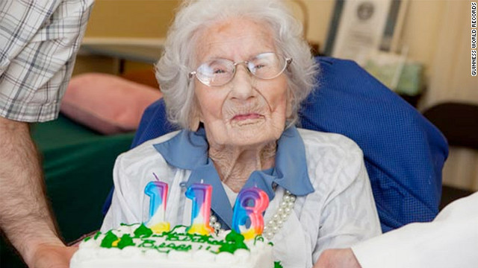

Besse Cooper of Monroe, Georgia, celebrates her 116th birthday. She was   
certified as the world's oldest person by Guinness World Records in 2011.

**STORY HIGHLIGHTS**

* Besse Cooper was one of the first women to vote in Georgia, helped sign others up to cast ballots
* Cooper lived in Monroe, Georgia, and her son says she died peacefully
* She once said she lived so long because she watched what she ate and didn't cause trouble
* Only eight people have ever been documented to have lived to age 116

**(CNN)** -- Before women gained the right to vote in 1920, Besse Cooper joined the suffrage movement. Then 24, the Georgia school teacher registered women to vote and spoke to others about the importance of having a voice in politics. Cooper voted in every election after the 19th Amendment was passed, save for two.

She died Tuesday, at age 116, only one of eight people recognized by the Guinness World Records to have lived that long.

Her son Sidney said his mother had her hair done Tuesday morning by a stylist at the assisted-living center where she had lived for the past 11 years but began to have trouble breathing. She died later in her room, peacefully, he said.

When asked for her secret to a long life, Cooper told the Guinness website earlier this year: "I mind my own business. And I don't eat junk food." Sidney Cooper, 77, said his mother was a strong, determined woman who, like the school teacher she was, could be a disciplinarian. She was fair and honest, he said, but "when she said something needed to be done, you'd better do it."

Besse Cooper was born in Sullivan County, Tennessee, on August 26, 1896. She began to go to school at age 5 -- yes, she walked from a log cabin -- to make sure one of her brothers attended. She grew to love going to class and eventually went to East Tennessee Normal School (now East Tennessee State University) in Johnson City to study education. When she graduated, she got a job earning $35 a month. When she heard from a friend she could make more in Georgia, she got a job in Monroe making twice as much. She married Luther Cooper in 1924, and he died in 1963. She never remarried.

Sidney Cooper said his mother always said her best years were when she was in her 80s. He will always remember her with her straw hat on, working in the flower garden, scratching weeds away with her hoe. She always had fresh-cut flowers in her home, and in her later years, her family would bring some to her room. She also loved to watch the news on television, her son said. "She was very intelligent," Sidney Cooper said. "She loved to read." Her eyesight had deteriorated, though, and she no longer read the Bible or any of the great works of fiction. Aside from a few heart issues, she was in "amazing" health, her son said, adding that she never complained of pain even in her final days.

Besse Cooper gained the distinction of being oldest living human from Guinness World Records in January 2011. She briefly moved to second on the list when the record keepers found a woman in Brazil who was 48 days older, but Maria Gomes Valentim died in June 2011, just weeks before her 115th birthday.

The oldest person to have ever lived, according to Guinness World Records, was Jeanne Louise Calment. She died in southern France in 1997 at the age of 122.

As for her voting record, Besse Cooper didn't vote this year. Neither she nor her husband voted in 1948. They thought Thomas Dewey was a shoo-in. Besse Cooper is survived by four children, 11 grandchildren, 13 great-grandchildren and two great-great grandchildren.

***Notes on my thoughts, reactions and questions as I read:***

**Article of the Week  
*World’s Oldest Person Dies at Age 116 (1210L)***

***Notes on my thoughts, reactions and questions as I read:***

**Article of the Week  
*World’s Oldest Person Dies at Age 116 (1210L)***

**Comprehension questions – answers may be in phrases. DIRECTIONS: Write five (5) comprehension questions of your own choosing. Answers should be found directly in the article.**



*7/8.RL.1*

***2.* Answer each question in one or more complete sentences.**

*According to the information presented in the article, to what does this woman attribute her longevity?*

*What types of literature did this woman read when her eyesight allowed?*

*Based on the information presented in the text, what would you infer were this woman’s religious views?*

*7/8.RL.2/4 & 7/8.L.4*

**Article of the Week  
*World’s Oldest Person Dies at Age 116 (1210L)***

**3.**  *Explain the author’s purpose in providing the “story highlights” section of the article. Rewrite the highlights using a bulleted list of four important pieces of information from the article.*

*7/8.RL.6*

**(**

**4.** *Explain this woman’s view on politics. Back your answer up with evidence cited directly from the text.*

*7/8.RL.6/8*