**Reading Article of the Week  
*Member of Secret WWII Navajo Code Talker Marine Unit Dies at 90 (1270L)***

**Instructions: COMPLETE ALL QUESTIONS AND MARGIN NOTES**

**Read** the following article carefully and **make notes in the margin** as you read.

Your notes should include:

* Comments that show that you **understand** the article. (A summary or statement of the main idea of important sections may serve this purpose.)
* Questions you have that show what you are **wondering** about as you read.
* Notes that differentiate between **fact** and **opinion**.
* Observations about how the **writer’s strategies** (organization, word choice, perspective, support) and choices affect the article.

Your **margin notes** are part of your score for this assessment.

Answer the questions carefully in **complete sentences** unless otherwise instructed.

**Student ____________________________Class Period__________________**

# Member of secret WWII Navajo Code Talker Marine unit dies at 90

A member of the famed Navajo Code Talkers, who used their rare and ancient language to outwit the Japanese during World War II, has died.

George Smith died on Oct. 30 at the Gallup Indian Medical Center in New Mexico, said Navajo Nation president Ben Shelly. Smith was 90.

"Our Navajo Code Talkers have been real life heroes to generations of Navajo people," Shelly [said in a statement](http://www.president.navajo-nsn.gov/?p=557). "They have brought pride to our Navajo people in so many ways."

In honor of Smith, the Navajo Nation flag will be flown at half-staff until sundown on Nov. 4. Smith was part of a Marine unit of Native Americans who created a complex and secret code based on the Navajo language. Because Navajo is an unwritten language that was passed through generations, it is difficult for a non-Navajo speaker to translate, [according to navajocodetalkers.org.](http://www.navajocodetalkers.org/)

The words of the code, which were committed to memory by the Code Talkers, were used in communications in key battles, such as Guadalcanal and Iwo Jima, the official site of the Code Talkers notes.

The Japanese never managed to [crack the code](http://www.cnn.com/2012/11/01/us/navajo-code-talker-dies/index.html?npt=NP1).

The 2002 movie ["Windtalkers"](http://movies.yahoo.com/movie/windtalkers/) starring Nicolas Cage is based on the Code Talkers' mission.

The identities of the Code Talkers were kept secret, even to friends and family, until 1968. Now, only a handful is living, according to navajocodetalkers.org.

Smith enlisted with the Marines in 1943. He achieved the rank of corporal while serving in World War II in the Pacific Theater. He fought in battles at Saipan, Tinian, and the Ryukyu Islands, and served in places such as Hawaii and Japan.

The Code Talkers and the secret code they developed saved countless lives and helped end the war.

After his service, Smith worked as a heavy equipment mechanic with Navajo Engineering Construction Authority.

"Code Talker Smith led an honorable life. He served his country, then provided for his family," Shelly said.

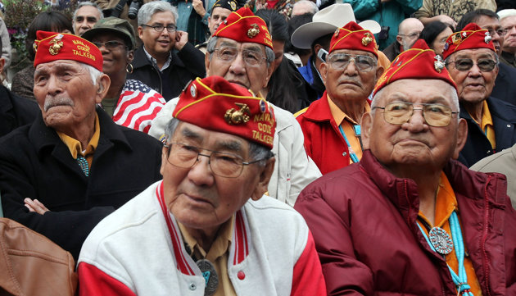

Members of the elite Navajo Code Talkers, the U.S. Marine unit that delivered unbreakable codes during World War II battles against the Japanese, on Veterans Day, November 11, 2009 in NYC.

***Notes on my thoughts, reactions and questions as I read:***

**Reading Article of the Week  
*Member of Secret WWII Navajo Code Talker Marine Unit Dies at 90 (1270L)***

***Notes on my thoughts, reactions and questions as I read:***

**Reading Article of the Week  
*Member of Secret WWII Navajo Code Talker Marine Unit Dies at 90 (1270L)***

**Comprehension questions – answers may be in phrases**

1. *Name the movie based on the Code Talkers’ mission.*
2. *Name the company in which Smith worked as a heavy equipment mechanic.*
3. *For what branch of the military did Smith serve?*
4. *On what date, and in what hospital did Smith pass away?*
5. *List two key battles in which the Navajo Code was a major factor.*
6. *What was Smith’s highest rank in the military?*

*7/8.RL.1*

***2.* Answer each question in one or more complete sentences.**

*The author mentions that George Smith led an “honorable life.” What two actions are mentioned in support of this “honorable life”?*

*Name two components of the Navajo language that make it useful as a military code.*

*How was the Navajo Code passed from Code Talker to Code Talker?*

*7/8.RL.2/4 & 7/8.L.4*

**Reading Article of the Week  
*Member of Secret WWII Navajo Code Talker Marine Unit Dies at 90 (1270L)***

**3.**  *Why would the identities of the Navajo Code Talkers be kept secret for so many years?   
(Hint: You may consider consulting navajocodetalkers.org for more information.)*

*7/8.RL.1/4/5*

**(**

**4.** *Based on the information provided in the article, how do the Navajo people feel about the Code Talkers and George Smith? Cite evidence from the text to back up your thoughts. Be specific, detailed, and thoughtful in your answer.*

*7/8.RL.1/8*