Name: ____________________ Hour: _________ October 14 - 18

**Reminder! We are expecting 8th grade caliber work. Minimal answers, incomplete answers, half-done answers do NOT count as complete work.

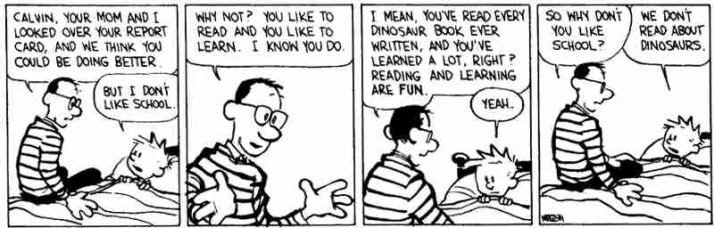

**What would help YOU do better in school? When are you really engaged in school? What is the most interesting part of your school day?**

 **Tuesday Tunes:** “Demons” by Imagine Dragons

|  |  |
| --- | --- |
| **“It’s where my demons hide.**  **It’s where my demons hide.**  **Don’t get too close**  **It’s dark inside.**  **It’s where my demons hide.**  **It’s where my demons hide.”** | What are your demons? What scares you the most? |

**Write it Right Wednesday- Circle the correct word in each parenthesis.**

**(It’s Its) fall and the leaves are so colorful.**

**The horse uses (its it’s) tail to swat flies in the barn.**

**(There They’re Their) is pie left in the frig if you want some for dessert.**

**When the twins get here (there their they’re) going to need a nap.**

**Once the students come to the dance, they need to put (there their they’re) book bags in the gym.**

C:\Users\Roby\AppData\Local\Microsoft\Windows\Temporary Internet Files\Content.IE5\1Q54FVLX\MC900056379[1].wmfTake A Stand Thursday~

Should schools be allowed to raise money by selling sugary snacks and pop to students?

REMEMBER! You are being graded on a 4 – 6 sentence response.

**Free Your Mind Friday:** Take a few minutes to reflect on something that you may have read, seen, listened to, or heard this week. Your reflection may be words, drawings, or a combination of both.