Name: ____________________ Hour: _________ Sept. 30 – Oct 4

**Reminder! We are expecting 8th grade caliber work. Minimal answers, incomplete answers, half-done answers do NOT count as complete work.

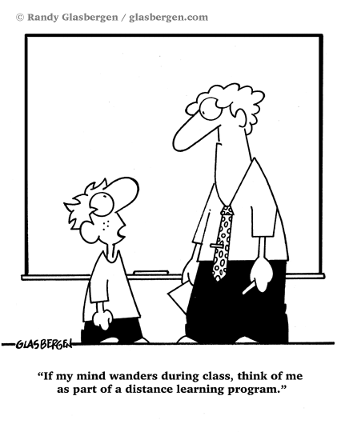

 **Tuesday Tunes:** Taylor Swift – ‘We are never, ever getting back together’

|  |  |
| --- | --- |
| **“We are never, ever, ever getting back together,**  **We are never, ever, ever getting back together,**  **You go talk to your friends, talk to my friends, talk to me**  **But we are never, ever, ever getting back together”** | Has anyone ever done anything to you that is impossible or hard to forgive? Have you done something to someone else that they didn’t forgive? |

**Write it Right Wednesday- Circle the correct word for each sentence.**

1. My parents will not (accept, except) any excuses for breaking curfew.
2. All the guys (accept, except) George were on time for the meeting.
3. My (advice, advise) to you is to calm down and count to ten.
4. I strongly (advice, advise) you to study your Math homework for the test.

C:\Users\Roby\AppData\Local\Microsoft\Windows\Temporary Internet Files\Content.IE5\1Q54FVLX\MC900056379[1].wmfTake A Stand Thursday~

Should teens be able to buy violent video games without a parent present?

**Free Your Mind Friday:** Take a few minutes to reflect on something that you may have read, seen, listened to, or heard this week. Your reflection may be words, drawings, or a combination of both.