Name: ____________________ Hour: _________ Sept. 23 – 27

**Reminder! We are expecting 8th grade caliber work. Minimal answers, incomplete answers, half-done answers do NOT count as complete work.

We will be choosing or have chosen self select or free choice books this year. What types of books do you like to read? What are your favorite genres? What are your least favorite? What are you willing to try this year?

[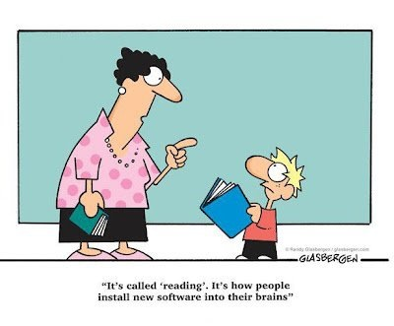](http://www.google.com/url?sa=i&source=images&cd=&cad=rja&docid=FMDcE3c0em_EiM&tbnid=gcxqf9pHmeCpFM:&ved=0CAgQjRwwAA&url=http://valems.wikispaces.com/-ELA+%26+Reading+Projects&ei=7ZM_Uo3vLbfl4AP_t4CQBQ&psig=AFQjCNHuyk9z8d9BPqsLOmkxJyy7aSHQBQ&ust=1379984749881002)

 **Tuesday Tunes:** “Brave” by Sara Bareilles

|  |  |
| --- | --- |
| “Say what you wanna say  And let the words fall out  Honestly, I wanna see you be brave  With what you want to say  And let the words fall out  Honestly, I wanna see you be brave” | What is the bravest thing you have said or done? If you haven’t done something you think is brave, who do you know who has? |

**Write it Right Wednesday**

**Correct the sentences:**

Their doesnt seam to be any reason to do that

If you insist on makeing that noise we will have know choice but to ground you

Come into the classroom ms j said and get your books out for todays lesson

C:\Users\Roby\AppData\Local\Microsoft\Windows\Temporary Internet Files\Content.IE5\1Q54FVLX\MC900056379[1].wmfTake A Stand Thursday~

Should there be additional or higher taxes on junk foods and snacks to encourage people to make healthier choices?

**Free Your Mind Friday:** Take a few minutes to reflect on something that you may have read, seen, listened to, or heard this week. Your reflection may be words, drawings, or a combination of both.