**Article of the Week**

***Driver’s License Issued to a Car with No Driver (1190L)***

**Instructions: COMPLETE ALL QUESTIONS AND MARGIN NOTES**

**Read** the following article carefully and **make notes in the margin** as you read.

Your notes should include:

* Comments that show that you **understand** the article. (A summary or statement of the main idea of important sections may serve this purpose.)
* Questions you have that show what you are **wondering** about as you read.
* Notes that differentiate between **fact** and **opinion**.
* Observations about how the **writer’s strategies** (organization, word choice, perspective, support) and choices affect the article.

Your **margin notes** are part of your score for this assessment.

Answer the questions carefully in **complete sentences** unless otherwise instructed.

**Student ____________________________Class Period__________________**

## Driver’s License Issued to a Car with No Driver

SF News – Nevada has just issued a license to a car without a driver.  The Google driverless car is equipped with an autopilot system that can navigate the car without the intervention of a human driver. The innovative car that has been introduced by Google doesn’t need anyone behind it to hit the road. This can be the ultimate advancement in cruise control; a self-driving car coming to the streets. Nevada is the first state in United States to allow these vehicles to operate in its streets. It is said that Florida may soon follow.

The technology is already used in passenger airplanes as automatic navigation system. If the human driver grabs the steering wheel or steps on the brake, he or she can take control of the vehicle just as a cruise control system would work.  The car uses cameras to spot traffic lights in the streets.

Currently, the Nevada state requires that a backup driver or passenger be present during its operation. The car is still a prototype and is not expected to be used widely for another ten years.

The automobile technology has surely come a long way since the invention of the wheel some 6000 years ago and since the founder of Ford Motor Company, Henry Ford, developed his first steam car factory in 1947.  But there has been one element throughout all these years that has been inseparable from any type of these vehicles and that has been a human controller (a driver).

In recent years, many of the tasks that were originally the responsibility of the driver have been taken away.  That, as examples, includes the automatic transmission replacing manual, the cruise control system that releases drivers from holding on same posture during long drives, and, quite possibly, the most advance help to drivers has been the introduction of the GPS system.

But all these technologies up until now have been there to aid the driver of the car and not to replace him or her.

The automatic navigation system, while at early stages, has been a dream for those who love science fiction.  While the core technology has already been in use in naval ships and in the skies by pilots, implementation of the technology on the ground faces many obstacles.

For one thing, passengers of the car need to come to trust it.  After all they are going to be in a lot of danger if the system, for any reason, fails to operate as expected.

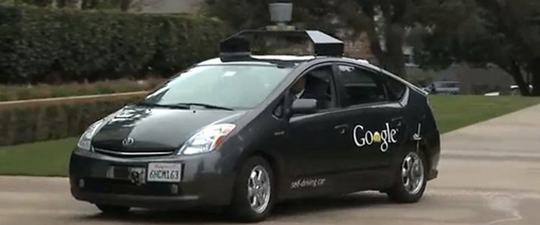

***Notes on my thoughts, reactions and questions as I read:***

**Article of the Week**

***Driver’s License Issued to a Car with No Driver (1190L)***

***Notes on my thoughts, reactions and questions as I read:***

**Article of the Week**

***Driver’s License Issued to a Car with No Driver (1190L)***

**Comprehension questions – answers may be in phrases.**

1. *When did Henry Ford develop his first steam car factory?*
2. *What company was this car introduced by?*
3. *How many years until these cars are expected to be used widely?*
4. *What does this car use to spot stop lights on the street?*

1. *What may be another state to allow vehicles to operate on their streets?*

*7/8.RL.1,2,4,10*

***2.* Answer each question in one or more complete sentences.**

*What is the first state in the U.S. that allows these vehicles to operate on the streets?*

*What does “inseparable” mean as used in this article?*

*What is one area where this technology is already used?*

*7/8.RL 1,2,4,10*

**Article of the Week**

***Driver’s License Issued to a Car with No Driver (1190L)***

***3.*** *Summarize this article in 25 words.*

*7/8.RL.2,10*

**(**

**4.**  *Do you think it is a good idea to use driverless cars in the future? Explain. Support your answer with evidence from the text.*

*7/8.RL, 10*